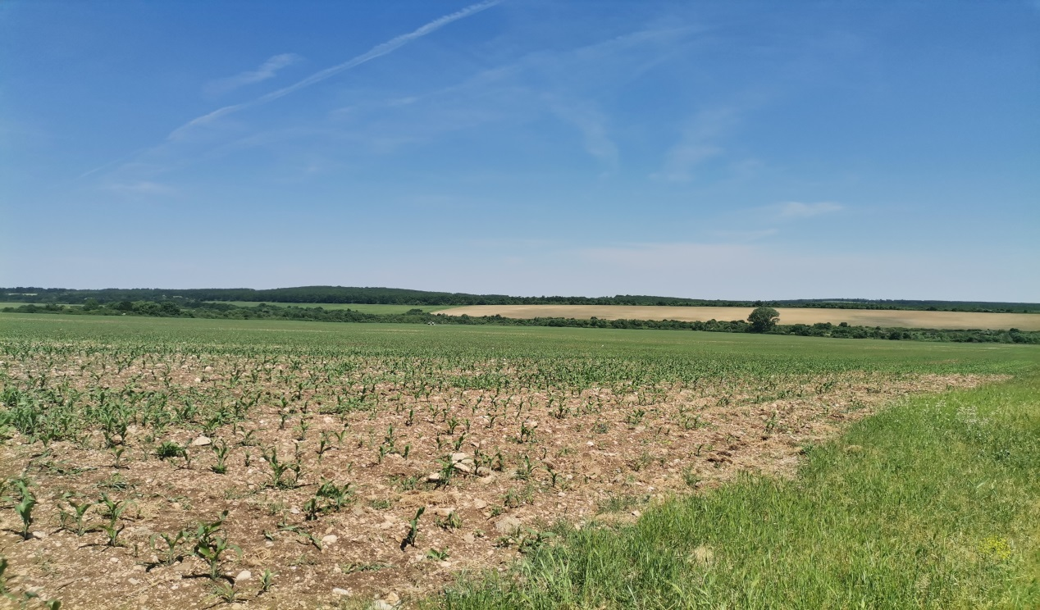
Institute of Agricultural Economics Agricultural Academy

INVITATION
to participate in
IX International Scientific Conference
"Agriculture and Food Supply: Markets and Policies"

October 25-26th, 2022

Institute of Agricultural Economics

Dear colleagues,

We are pleased to invite you to the 10-th International Scientific Conference "Agricultural Economics to Support Farming", motto: "Agriculture and Food Supply: Markets and Policies", October 25-26, 2022, organized by the Institute of Agricultural Economics, Agricultural Academy (AGRIACAD) and partnership with the European Research Network for Rural Development (ERDN).
The forum will be held in a hybrid format: online and in-person on October,25-26-th 2022. The conference is aimed at scientists, doctoral students and researchers from Bulgaria and abroad and provides the opportunity to participate with a presentation of scientific research, reports on a research topic and taking part in conference sessions and discussions.
Participation in the conference is free of registration fees for all speakers and guests who have expressed a desire to be included and have approved abstracts. The cost of attending the forum as well the costs of transport, hotel accommodation and meals are to be paid by the participants themselves. The attendance form of the conference will be in a hotel in the Borovets resort, 60 km from Sofia, and the hotel will be further specified by September 15, 2022, depending on the number of attendees.
Goal: academic and scientific scholars, representatives of business in agriculture, local administration and state bodies.
Thematic sections of the Conference:
- Food supply and effects of COVID-19;
- Competitiveness and effects of agricultural and commodity markets;
- Agricultural policies in the transition to a green economy;
- Opportunities and challenges for rural areas;
- Innovation, circular and bio-economy
Official languages:
English and by exception Bulgarian when presenting and English for the power point presentations and reports.
Remarks:
- The Abstracts which are submitted with deadline: August 30, 2022, in English
- Approval of participation: September 15, 2022
- The Paper Works which are submitted after determined deadline: October 30, 2022, in English

We sincerely hope that you will be among us and together we can continue the discussion about the future development of Bulgarian agriculture in the context of the expected changes in the CAP.
Papers are reviewed by the independent reviewer(s). After a positive assessment and approval, they will be submitted for publication in Bulgarian scientific publications, and referenced by the National Center for Information and Documentation, and those who receive the highest assessments/reviews will be offered for acceptance to scientific publications included in Web of Science, SCOPUS.

Technical propositions for writing the papers:

The text should be organized as follows:
Title; Author/s; Summary and keywords; Introduction; Materials and Methods; Results and Discussion; Conclusions
Volume: up to 10 standard pages, incl. graphs, figures, tables, and bibliography.
Page format: A4, portrait orientation. Margins: left – 2.5 cm, right – 2.5 cm, top – 2.5 cm, bottom – 2.5 cm. One-column text, line spacing – 1.
Title and name of the author(s) in Bulgarian and in English - in capital letters in bold Times New Roman - Size 14 pt; the name of the author(s) in one blank line below the title, Times New Roman- Size 12 pt.
Underline: in Bulgarian and in English - position, organization, email, Times New Roman - Size 10 pt
Keywords in Bulgarian - up to 5, Times New Roman - Size 10 pt.
Abstract in English - up to five lines across one blank line below the author(s) name Times New Roman - Size 10 pt.
Keywords in English - up to 5, Times New Roman - Size 10 pt.
The main text of the report in English - Times New Roman; Size – 12 pt with spacing – 1 line (Single); no extra space before and after each paragraph; two-way alignment; indent at the beginning of each new paragraph - 1.25 cm.
Tables are constructed in the text using Word Table; are numbered consecutively according to their citation; title above the table, italic, centered; it is desirable to collect the table on one page without turning the wide part of the sheet horizontally.
Figures are drawn using appropriate graphics programs; are numbered consecutively according to their citation; title below figure, italics, centered
Formulas are created using Word Equation.
Citation - APA Style (American Psychological Association)
Sources used are arranged alphabetically in ARA style (Georgiev, P. (2020) Agriculture Economics, Sofia: "IAE" Publishing House)
Contact information: First and last name, Times New Roman, 9 pt. Title and scientific degree of the authors, place of work, e-mail
File name: report, author's first and last name, separated by an underscore. (example: document_Ivan_Petrov.doc)
To contact the organizers
Ch. Assistant professor Angel Sarov, PhD – +359884 188 794
Ch. assistant professor Daniela Tsviatkova, PhD – +359884 189 372
Conference email: iae.conference2022@gmail.com

Application for participation:

Name, surname, academic position, scientific degree, organization (in Bulgarian) (please indicate the full author team in the order of author participation) ............................................................................................................................................................................................................................................................................................................
Name, surname, academic position, scientific degree, organization (in English) (please indicate the full author team in the order of author participation))
............................................................................................................................................................................................................................................................................................................
Email:
………………………………………………………………………………………………..........
.
Thematic sections of the Conference
…………………………………………………………………………………………………….

Title of the paper (in English):
..................................................................................................................................................................................................................................................................................................................................................................................................................................................................

Abstract (up to 200 words, formatted in one paragraph, with the following subheadings: purpose, material, methods, results, conclusions. It is not required to include literary sources in the abstract. It is to be completed in English only).............................................................................................................................................
...............................................................................................................................................................................................................................................................................................................................................................................................................................................................................................................................................................................................................................................................................................................................................................................................................................................................................................................................................................................................................................................................................................................................................................................................................................................

Keywords (up to 5 keywords, in English)
......................................................................................................................................................
.......................................................................................................................................................
Please indicate your participation:

Present:
Online:

Contact phone:
.........................................................................................................................................
For sending abstracts, confirmation of participation and sending full reports: iae.conference2022@gmail.com

