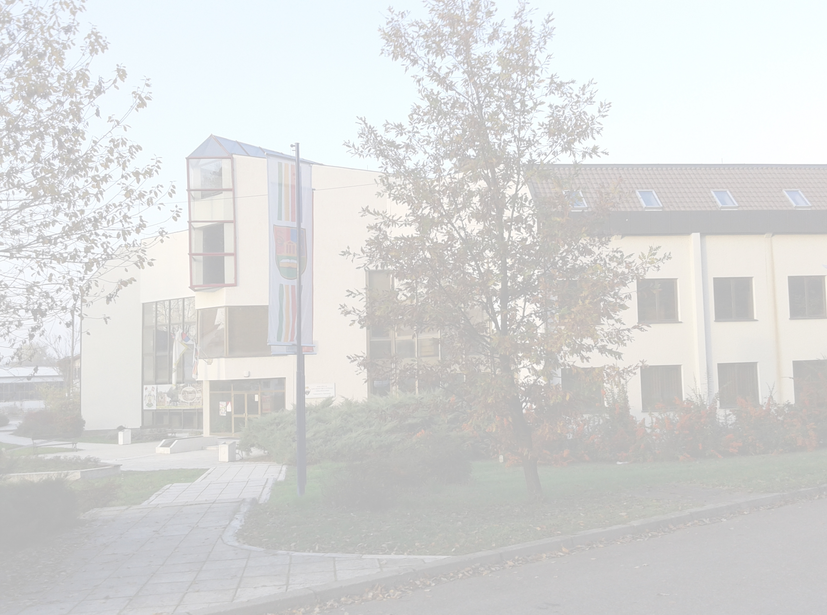




FACULTY OF HOTEL MANAGEMENT AND TOURISM IN VRNJAČKA BANJA

UNIVERSITY OF KRAGUJEVAC

FACULTY OF HOTEL MANAGEMENT AND TOURISM IN VRNJAČKA BANJA

Vojvođanska 5А, 36210 Vrnjačka Banja, Serbia

Fax:
(+381 36) 515 00 25

Phone:
(+381 36) 515 00 24

Е-mail:
hitvb@kg.ac.rs


Web site:
http://www.hit-vb.kg.ac.rs/

June 2-4th 2016
International Scientific Conference

„TOURISM IN FUNCTION OF DEVELOPMENT OF THE REPUBLIC OF SERBIA“

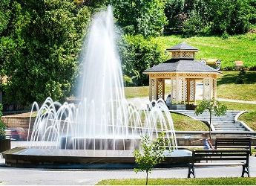
- Spa tourism in Serbia and experiences of other countries -

COORGANIZERS OF THE CONFERENCE |  | REGISTRATION FEE

*** Will subsequently be determined ***

*** Will subsequently be determined ***

TEMATIC SECTIONS OF THE CONFERENCE

*** I SECTION * * *

Tourism in function of development

* * * II SECTION * * *

Spa tourism in Serbia and experiences of other countries

PAPERS APPLICATION

- Abstracts have to be submitted not later than 30th January 2016.
- Complete papers have to be submitted strictly in e-form, by e-mail, no later than 22nd April 2016. The papers which arrive after specified date will not be taken into consideration for publishing!
- The papers must be in ENGLISH (Serbian authors have to submit also Serbian version of paper)
- All papers are subject to review, and only the papers accepted by 2 reviewers will be published in Thematic Proceedings, before the Conference.
- There may not be more than 2 authors per one paper and each author/co-author can have only 1 paper! Repeating the same authors/co-authors is NOT ALLOWED!

THE FIRST AUTHOR

Submits individually completed and technically prepared papers in electronic form, strictly in accordance to the TEMATIC SECTIONS OF THE CONFERENCE:

***I SECTION * * *

tanja.stanisic@kg.ac.rs

* * * II SECTION * * *

vesna.milovanovic@kg.ac.rs

TECHNICAL PROPOSITIONS FOR WRITING THE PAPERS

STRUCTURE, SIZE AND METHOD OF PAPER WRITING

- Paper must contain title, full name and surname of the author/co-author, abstract, key words, introduction, elaboration - clearly and logically structured in the form of optional number of subtitles, conclusion and literature.

- Paper must not be shorter than 16 pages (max 18 pages), including abstract, charts, tables, pictures, schemes, enclosures and literature.
.
- Paper has to be written in program Word for Windows, format B5 (ISO) 17,6 x 25 cm or Еnvelope B5 17,6 x 25 cm (Page Setup, Paper Size), font size 12, Times New Roman, alignment Fully Justified, spacing Single (Paragraph, Line Spacing), with one line spacing between the paragraphs (key Enter), without indentation the first line of paragraph

- Page margins must be 2,5 cm - Тop, Bottom, Left, Right.
- Pages numbering - centered, bottom of the page.
- Introduction, subtitles, conclusion and literature in the paper must be centered, without numbering, written in small letters with first capital letter, font size 12, Times New Roman (Bold).
- Above and below the introduction, subtitle, conclusion and literature must make one line spacing (key Enter)!!!

FIRST PAGE OF THE PAPER

- Title of the paper: maximum 2 lines, centered, in CAPITAL LETTERS, font size 12, Times New Roman (Bold).
- Full name and surname of the author/co-author, written in small letters, is below the title with 2 lines spacing (key Enter), font size 12, Times New Roman (Italic).

- In a footnote, it is obligatory to give full name and surname of the author/co-author, title, vocation, name and address of the master institution, telephone number and e-mail address, font size 10, Times New Roman.
ABSTRACT OF THE PAPER

- Abstract title centered, in small letters, with 2 lines spacing below the author name (key Enter), font size 12, Times New Roman (Bold).
- Text of the abstract, not over 150 words, with one line spacing (key Enter) from the abstract title, font size 12, Times New Roman (Italic).

- Below the abstract text, with one line spacing (key Enter), are Key words: maximally 6 (Italic), font size 12, Times New Roman.

CHARTS, TABLES, PICTURES, SCHEMES AND ENCLOSURES

- In black-and-white or color technique, must contain title and source, insert in the paper's text, numerate chronologically and centred, Times New Roman, table header (Bold).

- Size of CHART, PICTURE, SCHEME and ENCLOSURE adjust to the page format and page margins, as well as the font size in the TABLE, so they can be clearly and entirely shown on one page! BREAKS ARE FORBIDDEN!
- Title (Italic), font size 12, alignment Fully Justified.

- Source with reference (Italic), font size 12, alignment Fully Justified

LITERATURE

- Literature has to be at the end of the paper, after conclusion, listed by one line spacing (key Enter) in alphabetical order according to the author's surname or institution (if it is as author), font size 12, Times New Roman.
- The reference should contain the following elements and follow the order of appearance:

- Surname and name of the author/co-author or institution as the author
- Year of publishing, in brackets ():
- Title of the paper (Italic),
- Title of publication/meeting,
- Title and location of publisher/place and date of the meeting,
- Volume and number of publication,
- Pages from-to.

- The references in form of INTERNET DOCUMENT (pdf, word, powerpoint, excel etc.) have to be shown also in alphabetical order according to the author's surname or institution as the author (if the author or institution as the author is unknown, it has to be classified according to the document's title), and should contain the following elements and follow the order of appearance:

- Surname and name of the author/co-author or institution as the author,
- Title of document (Italic),
- Full internet address,
- Date when the web-site was visited, in brackets ().

- In case when INTERNET REFERENCE in form of certain information/data from some web-site, where the authors, institution as the author and document title are unknown, mentioned reference has to be listed also in alphabetical order, according to the text title on the web-site, as well as it should contain the following elements and to follow the chronology of allegation:
- Title of the text on web-site,
- Full internet address,

- Date when web-site was visited, in brackets ().

VENUE OF THE INTERNATIONAL SCIENTIFIC CONFERENCE

Faculty of Hotel Management and Tourism in Vrnjačka Banja

Vojvođanska 5А, 36210 Vrnjačka Banja, Serbia

OFFICIAL LANGUAGE OF THE
INTERNATIONAL SCIENTIFIC CONFERENCE

***ENGLISH ***
REMARKS

Dear authors,

- The papers which are submitted after determined deadline (22nd April 2016), WILL NOT BE TAKEN INTO CONSIDERATION!

- The papers with less than 16 pages, or longer than 18 pages, technically unadjusted to the propositions, WILL NOT BE TAKEN INTO CONSIDERATION!

- If there are more than 2 authors on the paper, PAPER WILL NOT BE TAKEN INTO CONSIDERATION!
- If there are 2 papers with the same author/coauthor, PAPER WILL NOT BE TAKEN INTO CONSIDERATION!

- It is an OBLIGATION to check grammar and spelling mistakes in the paper!

- IMPORTANT DATES:
- 25.12.2015. Defining introductory expositions
- 30.01.2016. Submission of abstracts
- 19.02.2016. Confirmation of acceptance of abstracts
- 27.02.2016. Registration of presentations of companies and institutions, registration of participants without papers
- 22.04.2016. Submission of complete papers
- 02.06.2016. Arrival and registration of participants
- 02.06.2016. Opening the conference, introductory expositions
- 03.06.2016. Excursion, working in sections, a gala dinner
- 04.06.2016. Working in sections and/or a round table, conclusions of the conference, promotion of publications of the Faculty of Hotel Management and Tourism in Vrnjačka Banja.

Thank You for understanding,

ORGANIZATIONAL BOARD OF THE CONFERENCE,

Faculty of Hotel Management and Tourism in Vrnjačka Banja

